**Automobile Service Center Management System**

**I. Three Project Ideas**

1. **Project Title:** **Community Library Management System**
2. **Project Title:** **Gym and Fitness Center Membership System**
3. **Project Title:** **Automobile Service Center Management System**

**II. Identified Current Business Processes**

**i) Community Library:**

* Manual record-keeping of books in a ledger.
* Members register by filling out a paper form.
* Book borrowing and returns are logged in a notebook. Fines for late returns are calculated manually.
* Staff manually check for book availability.

**ii) Gym and Fitness Center:**

* Membership registration and payment are handled with paper forms and cash/point-of-sale machine.
* Member check-ins are done by staff visually recognizing members or checking a paper list.
* Class scheduling is done on a whiteboard or paper calendar.
* Trainer assignments and payment tracking are managed in spreadsheets.

**iii) Automobile Service Center:**

* Customer and vehicle details are recorded on job cards.
* Service history is maintained in physical files.
* Mechanics manually write down parts used on a job card.
* Billing is calculated manually based on the job card, leading to errors and delays.

III. Problem Statements

i) Community Library:

The current manual system is prone to errors, inefficient for tracking book availability and member activity, and makes it difficult to generate reports on popular books or overdue items. It is time-consuming for both members and staff.

ii) Gym and Fitness Center:

The lack of an integrated system leads to difficulties in managing member access, tracking attendance, scheduling classes efficiently, and managing payroll for trainers. This results in a poor member experience and operational inefficiencies.

iii) Automobile Service Center:

Reliance on paper-based job cards causes disorganization, loss of vehicle service history, inaccuracies in billing, and an inability to manage inventory of spare parts effectively. This hurts customer trust and business profitability.

**IV. Proposed Business Processes (for the selected idea)**

Let's select the **Automobile Service Center Management System** for the detailed design.

The new system will streamline operations through the following digital processes:

1. **Customer & Vehicle Registration:** New customers and their vehicles are registered in the system, creating a permanent record.
2. **Service Job Creation:** When a customer arrives, a service job is created and linked to their vehicle.
3. **Mechanic Assignment:** A mechanic is assigned to the job.
4. **Parts Management:** Parts used for the job are selected from the inventory, which automatically updates stock levels.
5. **Billing & Invoice Generation:** Upon job completion, the system automatically generates an invoice calculating the total cost (labor + parts).
6. **Service History Tracking:** The system maintains a complete history of all services performed on every vehicle.

**V. Entities and Attributes**

From the proposed processes, we can identify the following entities and their attributes:

1. **Customer**
   * CustomerID (Primary Key)
   * FirstName
   * LastName
   * PhoneNumber
   * Email
2. **Vehicle**
   * VehicleID (Primary Key)
   * LicensePlate (Unique)
   * Make
   * Model
   * Year
   * CustomerID (Foreign Key)
3. ServiceJob

* JobID (Primary Key)
* VehicleID (Foreign Key)
* MechanicID (Foreign Key)
* DateReceived
* DateCompleted
* JobDescription
* LaborCost

1. Mechanic

* MechanicID (Primary Key)
* FirstName
* LastName
* Specialization

1. Part

* PartID (Primary Key)
* PartName
* Description
* UnitPrice
* StockQuantity

1. JobParts (This is a Linking/Associative Entity to resolve the many-to-many relationship between ServiceJob and Part)

* JobID (Composite Primary Key, Foreign Key)
* PartID (Composite Primary Key, Foreign Key)
* QuantityUsed

database.jpg

JPG 71.55KB

Of course. This is an excellent exercise in systems analysis and database design. I will outline three distinct ideas, analyze them, and then select one to model in detail, including the ERD.

**I. Three Project Ideas**

1. **Project Title:** **Community Library Management System**
2. **Project Title:** **Gym and Fitness Center Membership System**
3. **Project Title:** **Automobile Service Center Management System**

**II. Identified Current Business Processes**

**i) Community Library:**

* Manual record-keeping of books in a ledger.
* Members register by filling out a paper form.
* Book borrowing and returns are logged in a notebook. Fines for late returns are calculated manually.
* Staff manually check for book availability.

**ii) Gym and Fitness Center:**

* Membership registration and payment are handled with paper forms and cash/point-of-sale machine.
* Member check-ins are done by staff visually recognizing members or checking a paper list.
* Class scheduling is done on a whiteboard or paper calendar.
* Trainer assignments and payment tracking are managed in spreadsheets.

**iii) Automobile Service Center:**

* Customer and vehicle details are recorded on job cards.
* Service history is maintained in physical files.
* Mechanics manually write down parts used on a job card.
* Billing is calculated manually based on the job card, leading to errors and delays.

**III. Problem Statements**

**i) Community Library:**  
The current manual system is prone to errors, inefficient for tracking book availability and member activity, and makes it difficult to generate reports on popular books or overdue items. It is time-consuming for both members and staff.

**ii) Gym and Fitness Center:**  
The lack of an integrated system leads to difficulties in managing member access, tracking attendance, scheduling classes efficiently, and managing payroll for trainers. This results in a poor member experience and operational inefficiencies.

**iii) Automobile Service Center:**  
Reliance on paper-based job cards causes disorganization, loss of vehicle service history, inaccuracies in billing, and an inability to manage inventory of spare parts effectively. This hurts customer trust and business profitability.

**IV. Proposed Business Processes (for the selected idea)**

Let's select the **Automobile Service Center Management System** for the detailed design.

The new system will streamline operations through the following digital processes:

1. **Customer & Vehicle Registration:** New customers and their vehicles are registered in the system, creating a permanent record.
2. **Service Job Creation:** When a customer arrives, a service job is created and linked to their vehicle.
3. **Mechanic Assignment:** A mechanic is assigned to the job.
4. **Parts Management:** Parts used for the job are selected from the inventory, which automatically updates stock levels.
5. **Billing & Invoice Generation:** Upon job completion, the system automatically generates an invoice calculating the total cost (labor + parts).
6. **Service History Tracking:** The system maintains a complete history of all services performed on every vehicle.

**V. Entities and Attributes**

From the proposed processes, we can identify the following entities and their attributes:

1. **Customer**
   * CustomerID (Primary Key)
   * FirstName
   * LastName
   * PhoneNumber
   * Email
2. **Vehicle**
   * VehicleID (Primary Key)
   * LicensePlate (Unique)
   * Make
   * Model
   * Year
   * CustomerID (Foreign Key)
3. **ServiceJob**
   * JobID (Primary Key)
   * VehicleID (Foreign Key)
   * MechanicID (Foreign Key)
   * DateReceived
   * DateCompleted
   * JobDescription
   * LaborCost
4. **Mechanic**
   * MechanicID (Primary Key)
   * FirstName
   * LastName
   * Specialization
5. **Part**
   * PartID (Primary Key)
   * PartName
   * Description
   * UnitPrice
   * StockQuantity
6. **JobParts** (This is a *Linking/Associative Entity* to resolve the many-to-many relationship between ServiceJob and Part)
   * JobID (Composite Primary Key, Foreign Key)
   * PartID (Composite Primary Key, Foreign Key)
   * QuantityUsed

**ERD DIAGRAM REPRESENTATION**

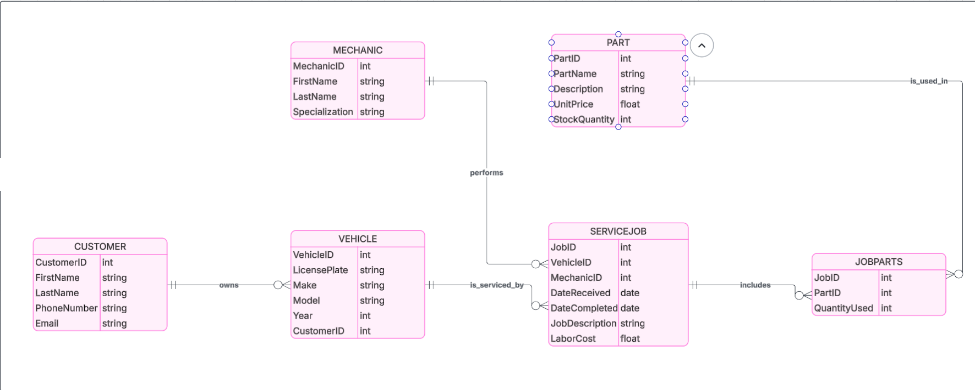

**Summary of Multiplicity Constraints (Cardinality):**

* **Customer -- Vehicle:** One-to-Many (1:M)
  + One Customer can own Many Vehicles.
  + One Vehicle is owned by One Customer.
* **Vehicle -- ServiceJob:** One-to-Many (1:M)
  + One Vehicle can have Many ServiceJobs.
  + One ServiceJob is for One Vehicle.
* **Mechanic -- ServiceJob:** One-to-Many (1:M)
  + One Mechanic can be assigned to Many ServiceJobs.
  + One ServiceJob is assigned to One Mechanic (at a time; this could be expanded to Many-to-Many).
* **ServiceJob -- Part:** Many-to-Many (M:N)
  + This is resolved by the **JobParts** linking table.
  + One ServiceJob can require Many Parts.
  + One Part can be used in Many ServiceJobs.